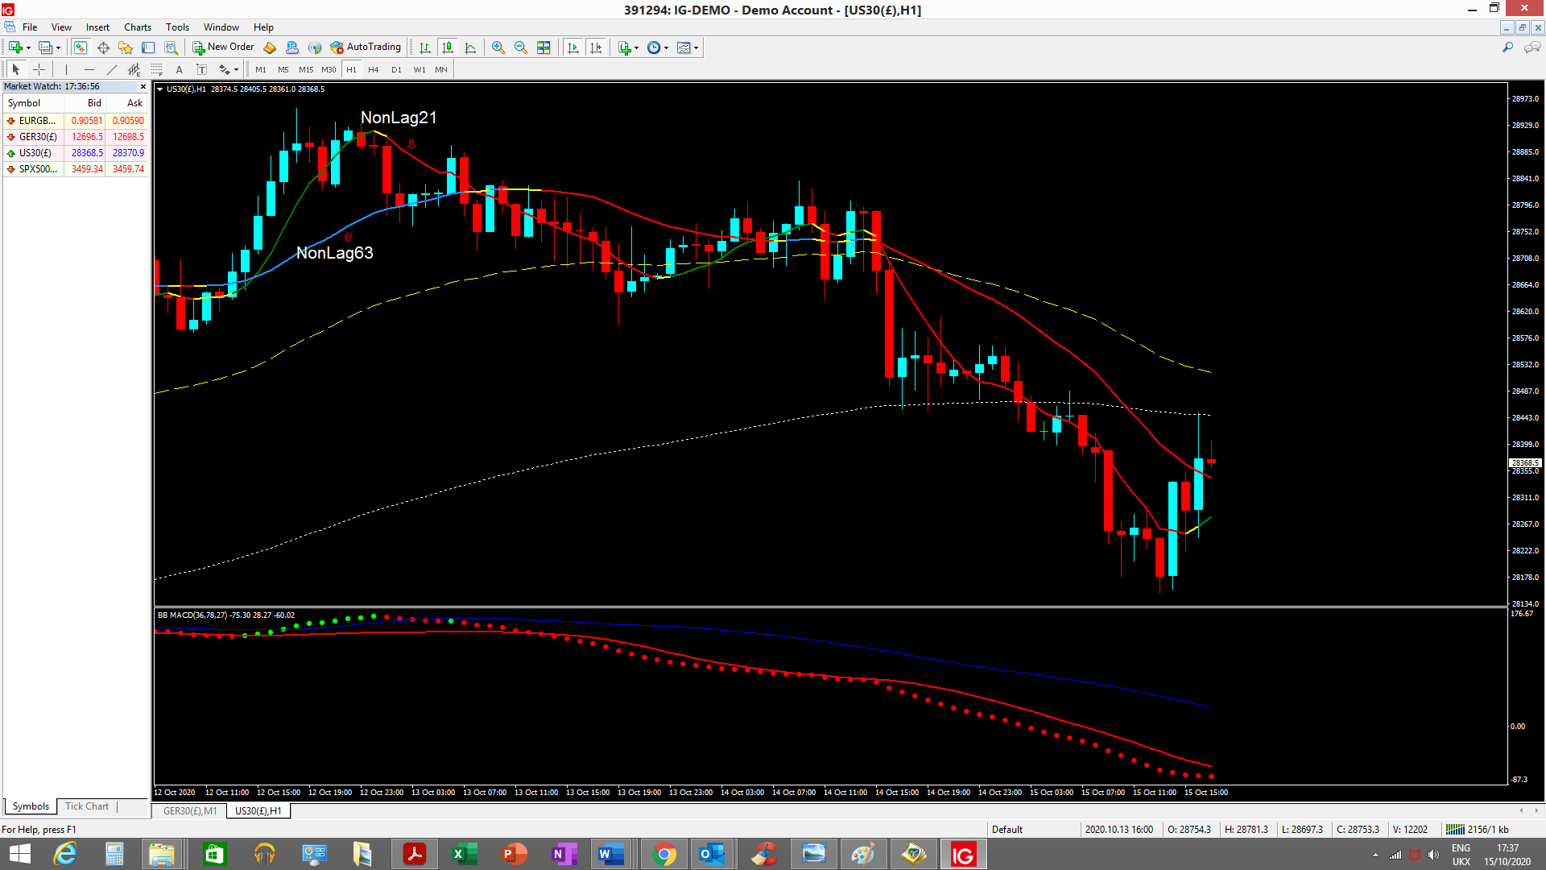
See changes in both short term and long term non lag – yellow indicates change in direction

