Good Signal +3 Condition and ADX is positive slope (take the bullish trade)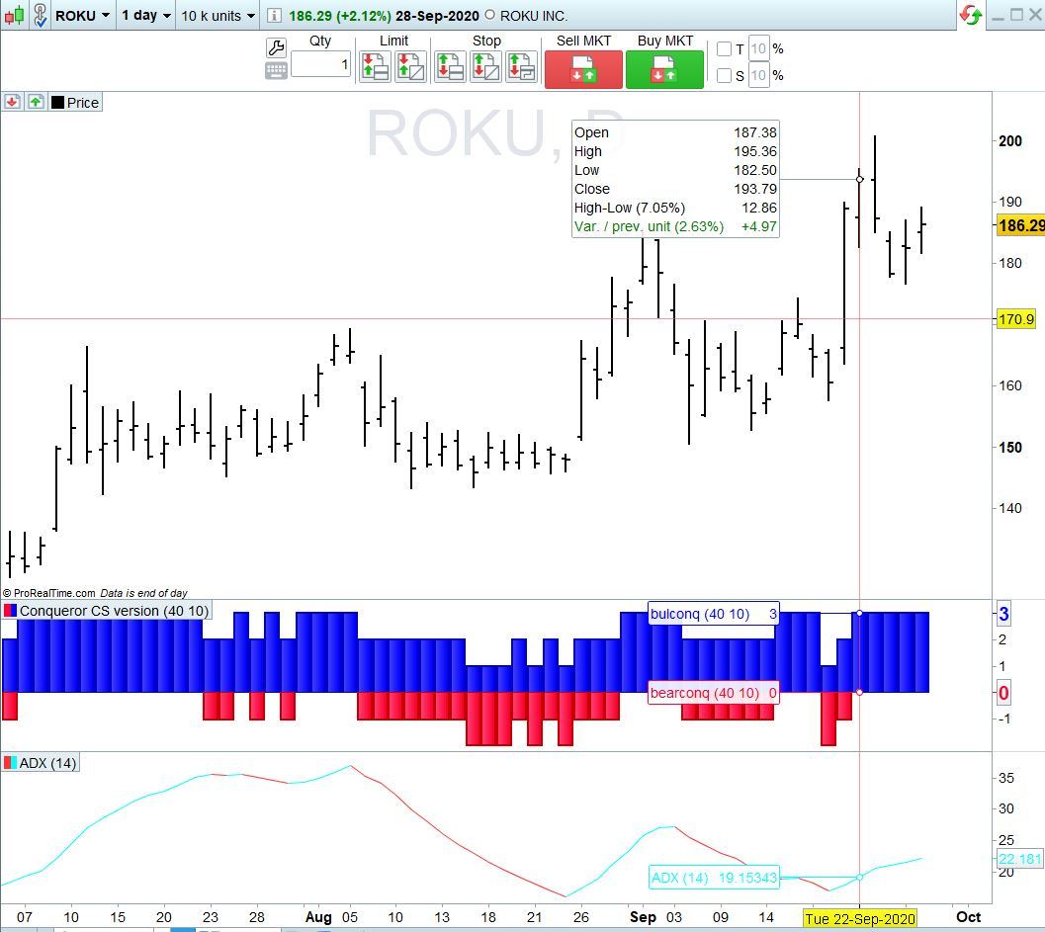

Good Signal +3 but Negative ADX slope (Do NOT take the bullish trade)
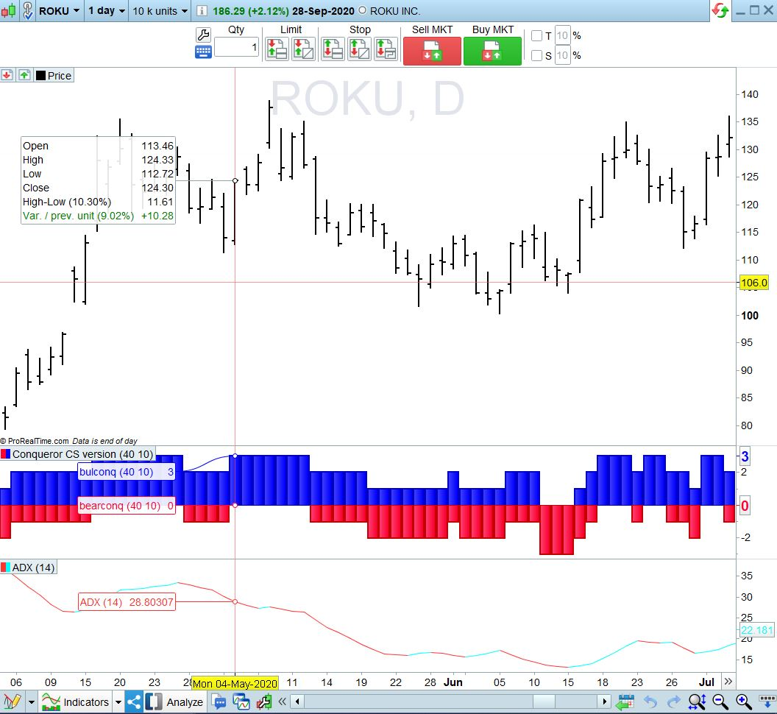

Good signal -3 and Positive ADX slope (take the bearish trade)
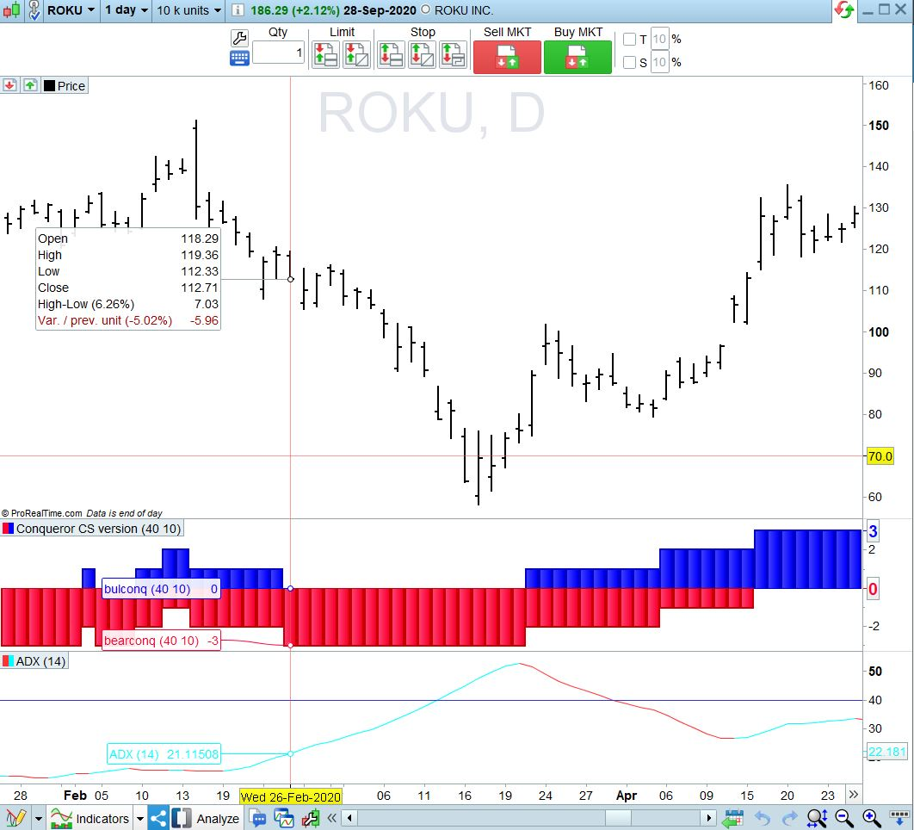

Good signal -3 but negative ADX slope (Do NOT take the Bearish trade)
