Hull Trend with Kahlman

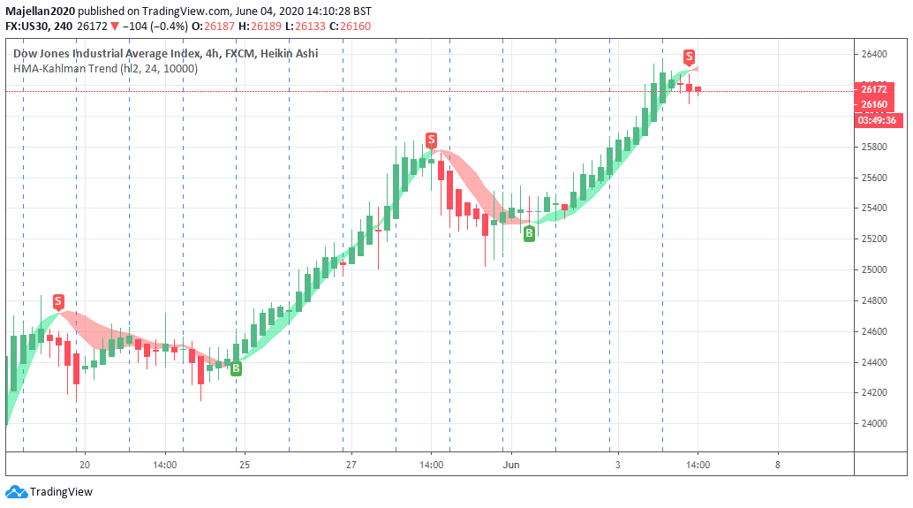

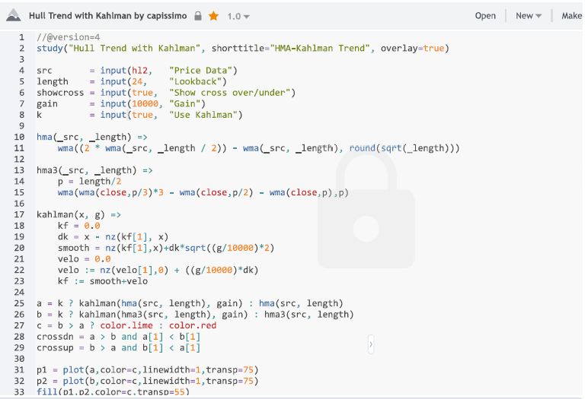

Source Code – Hull Trend with Kahlman – from TradingView

//@version=4
study("Hull Trend with Kahlman", shorttitle="HMA-Kahlman Trend", overlay=true)

src = input(hl2, "Price Data")
length = input(24, "Lookback")
showcross = input(true, "Show cross over/under")
gain = input(10000, "Gain")
k = input(true, "Use Kahlman")

hma(_src, _length) =>
wma((2 * wma(_src, _length / 2)) - wma(_src, _length), round(sqrt(_length)))

hma3(_src, _length) =>
p = length/2
wma(wma(close,p/3)*3 - wma(close,p/2) - wma(close,p),p)

kahlman(x, g) =>
kf = 0.0
dk = x - nz(kf[1], x)
smooth = nz(kf[1],x)+dk*sqrt((g/10000)*2)
velo = 0.0
velo := nz(velo[1],0) + ((g/10000)*dk)
kf := smooth+velo

a = k ? kahlman(hma(src, length), gain) : hma(src, length)
b = k ? kahlman(hma3(src, length), gain) : hma3(src, length)
c = b > a ? color.lime : color.red
crossdn = a > b and a[1] < b[1]
crossup = b > a and b[1] < a[1]

p1 = plot(a,color=c,linewidth=1,transp=75)
p2 = plot(b,color=c,linewidth=1,transp=75)
fill(p1,p2,color=c,transp=55)

plotshape(showcross and crossdn ? a : na, location=location.absolute, style=shape.labeldown, color=color.red, size=size.tiny, text="S", textcolor=color.white, transp=0, offset=-1)
plotshape(showcross and crossup ? a : na, location=location.absolute, style=shape.labelup, color=color.green, size=size.tiny, text="B", textcolor=color.white, transp=0, offset=-1)

