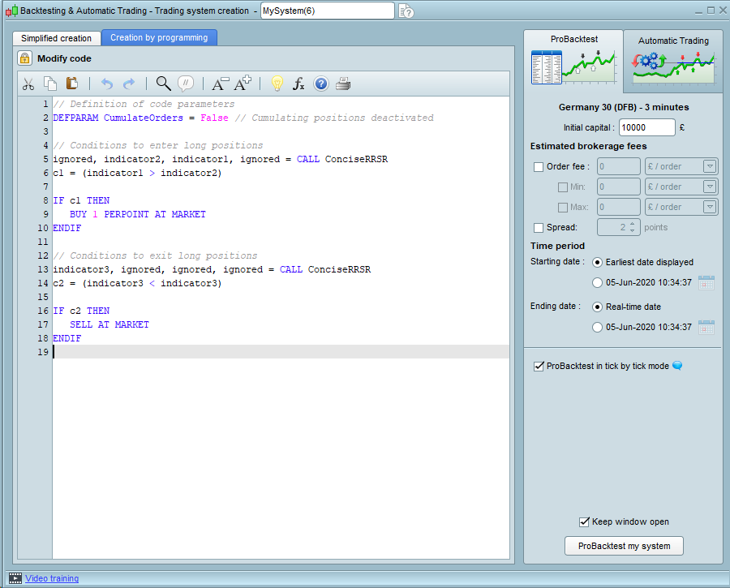

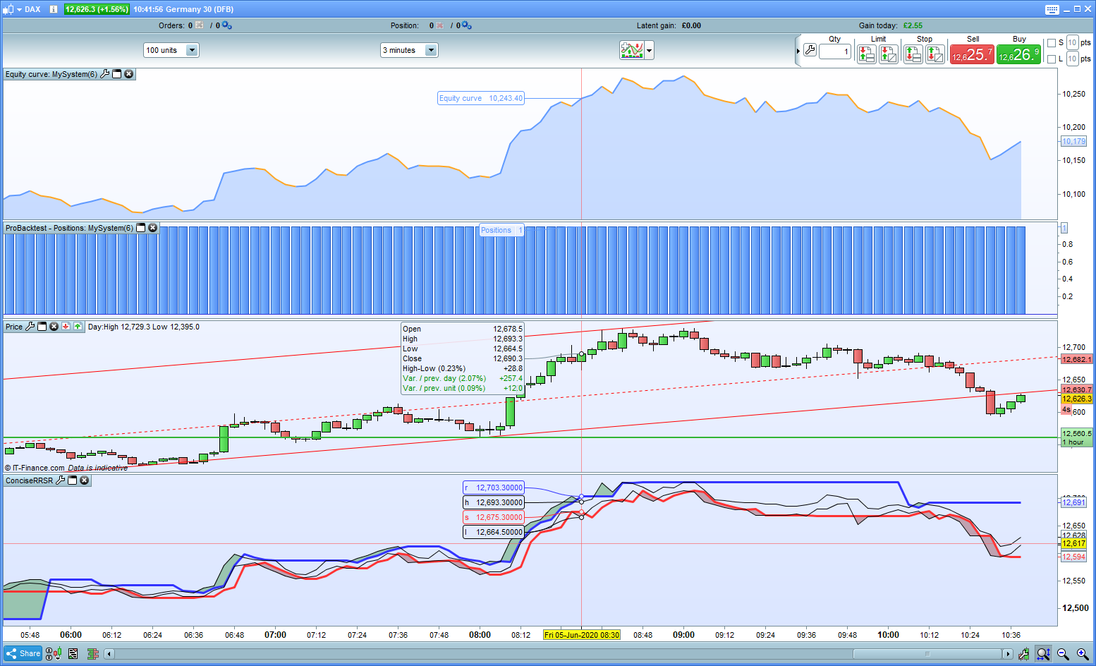
L < s so it should have sold…. It did not
It also went long at the wrong point…
My previous and similar efforts all worked

