Friday (red candle) and today (Monday so far):
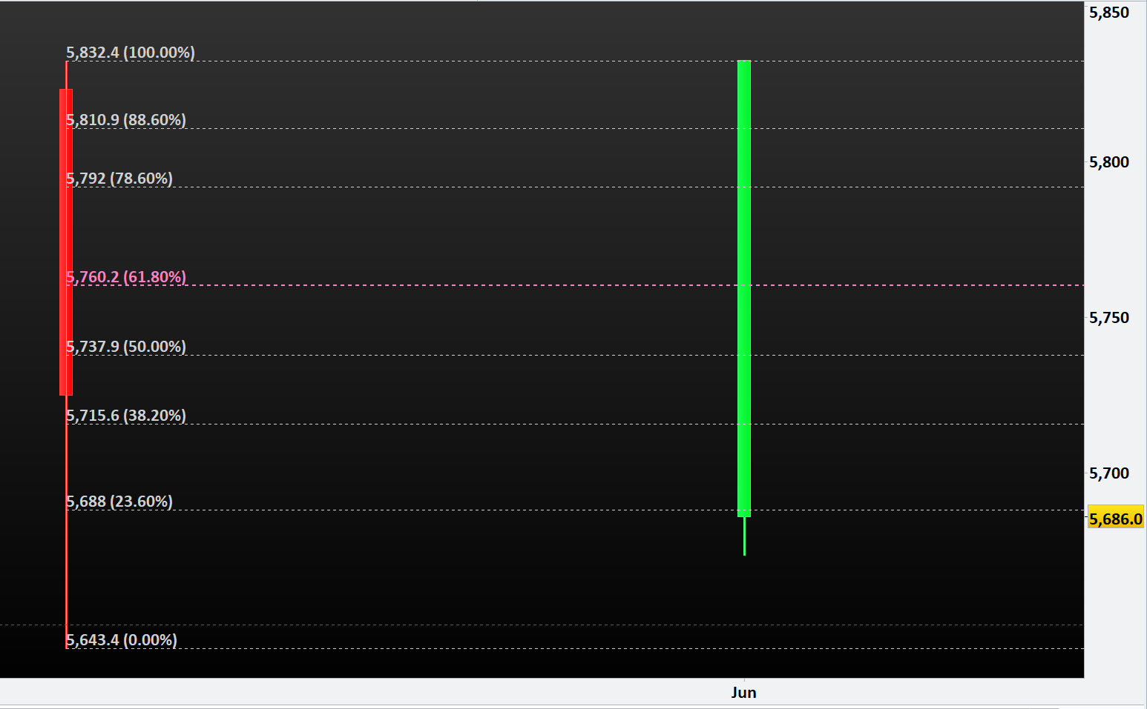
New Code: is not matching with Fibonacci drawn from yesterday’s low to high:
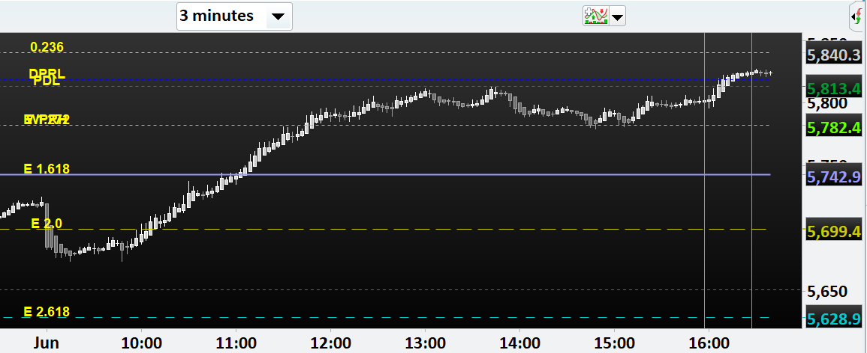

Old Code: is matching with Fibonacci drawn from yesterday’s low to high:
