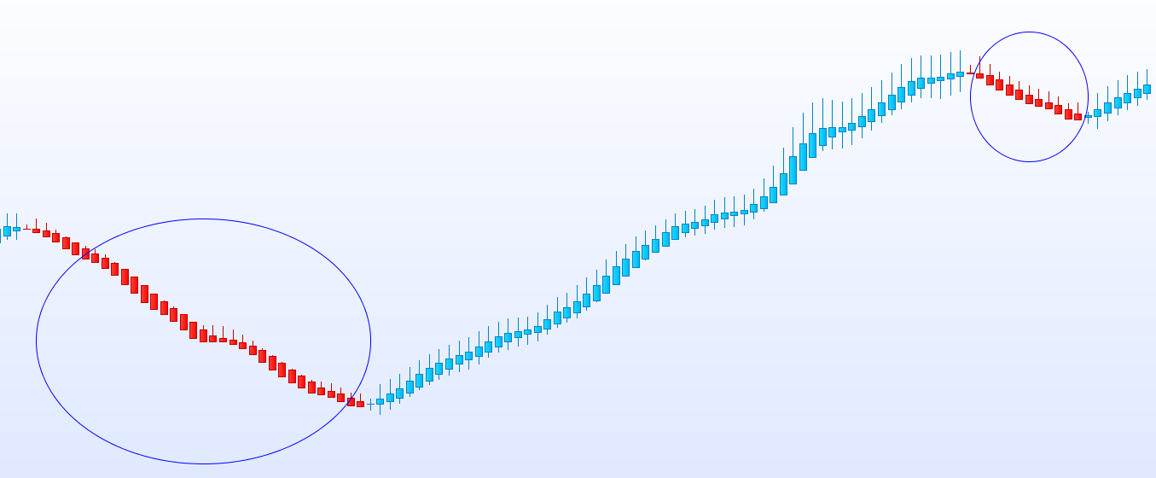

//PRC_HPT Heikin Ashi Smoothed | indicator
//25.04.2017
//Nicolas @ www.prorealcode.com
//Sharing ProRealTime knowledge
//translated from MT4 indicator code

//---settings
MaPeriod=6
MaPeriod2=2
//---end of settings

once maOpen=Open
once maClose=Close
once maLow=Low
once maHigh=High

if barindex>0 then
maOpen=(maOpen[1]*(MAperiod-1)+Open)/MAPeriod
maClose=(maClose[1]*(MAperiod-1)+Close)/MAPeriod
maLow=(maLow[1]*(MAperiod-1)+Low)/MAPeriod
maHigh=(maHigh[1]*(MAperiod-1)+High)/MAPeriod

haOpen=(ExtMapBuffer5[1]+ExtMapBuffer6[1])/2
haClose=(maOpen+maHigh+maLow+maClose)/4
haHigh=Max(maHigh, Max(haOpen, haClose))
haLow=Min(maLow, Min(haOpen, haClose))
if (haOpen<haClose) then
r=0
g=191
b=255
ExtMapBuffer7=haLow
ExtMapBuffer8=haHigh
else
r=255
g=10
b=0
ExtMapBuffer7=haHigh
ExtMapBuffer8=haLow
endif
ExtMapBuffer5=haOpen
ExtMapBuffer6=haClose

ExtMapBuffer1=weightedaverage[MAperiod2](ExtMapBuffer7)
ExtMapBuffer2=weightedaverage[MAperiod2](ExtMapBuffer8)
ExtMapBuffer3=weightedaverage[MAperiod2](ExtMapBuffer5)
ExtMapBuffer4=weightedaverage[MAperiod2](ExtMapBuffer6)
endif
DRAWCANDLE(ExtMapBuffer3,ExtMapBuffer2,ExtMapBuffer1,ExtMapBuffer4) coloured(r,g,b)

short = ExtMapBuffer7[1]>ExtMapBuffer8[1] and ExtMapBuffer7[2]<ExtMapBuffer8[2] and ExtMapBuffer7[0]>ExtMapBuffer8[0]
long = ExtMapBuffer7[1]<ExtMapBuffer8[1] and ExtMapBuffer7[2]>ExtMapBuffer8[2] and ExtMapBuffer7[0]<ExtMapBuffer8[0]

RETURN long as "long signal", short as "short signal"

