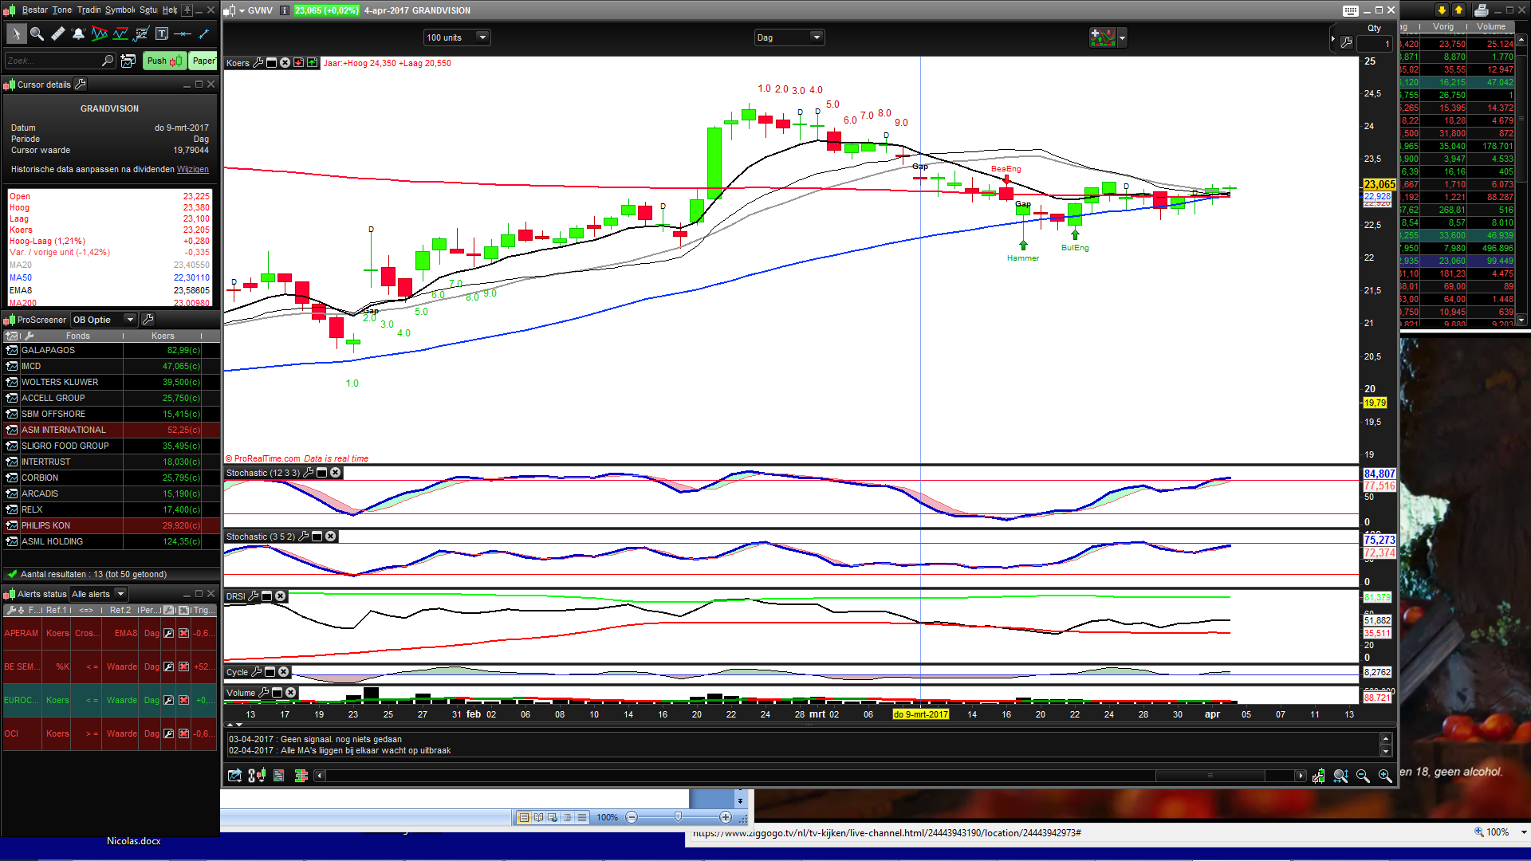
At the lowest arrow it doesnt start at the correct bar. The close of that bar is not higher then the 4th before that. It looks like normally a downswing should start.The correct place should be where now the 2.0 starts since there the closing price is higher then the closing price of 4th bar before that
The high arrow shows the start of the downswing which should have started at 3.0 cause thats the First time closing price was lower then the 4th bar before that.
Also after that downswing a new downswing should start after the resting dayafter 9.0
Hope it makes a little sense
Rgds John

