A very basic screener:
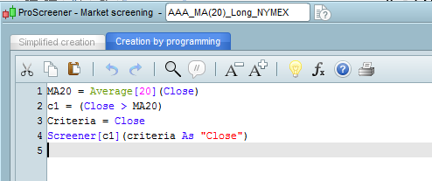

These are the results:
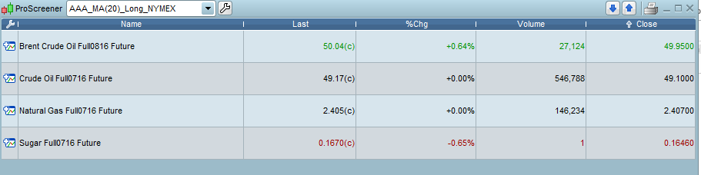

This is the chart that opens:
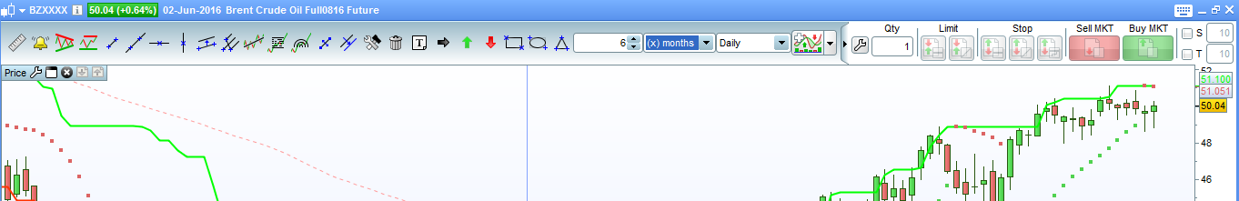
The closing price is different to the screener.

These are the settings I have saved after your email:
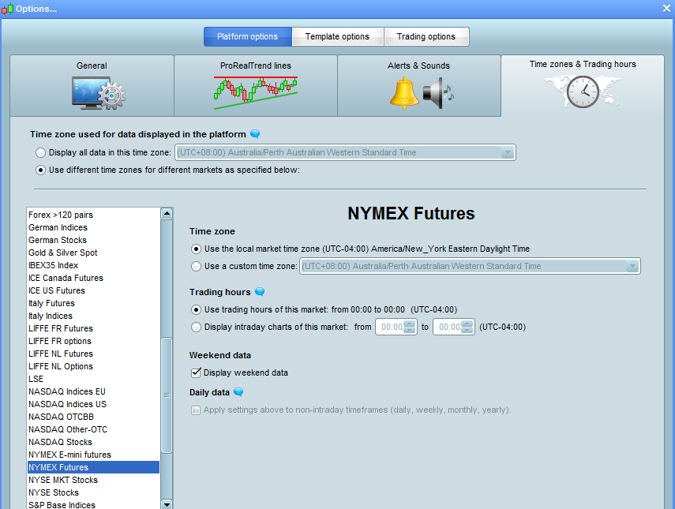

The same screener on FX:
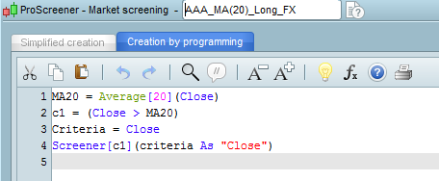

These are the results:
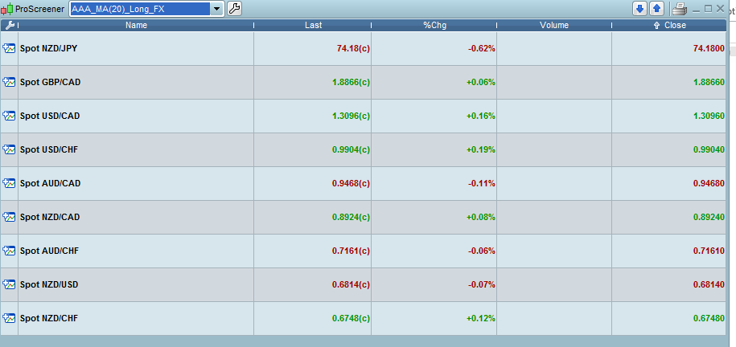

And the NZD/JPY chart:
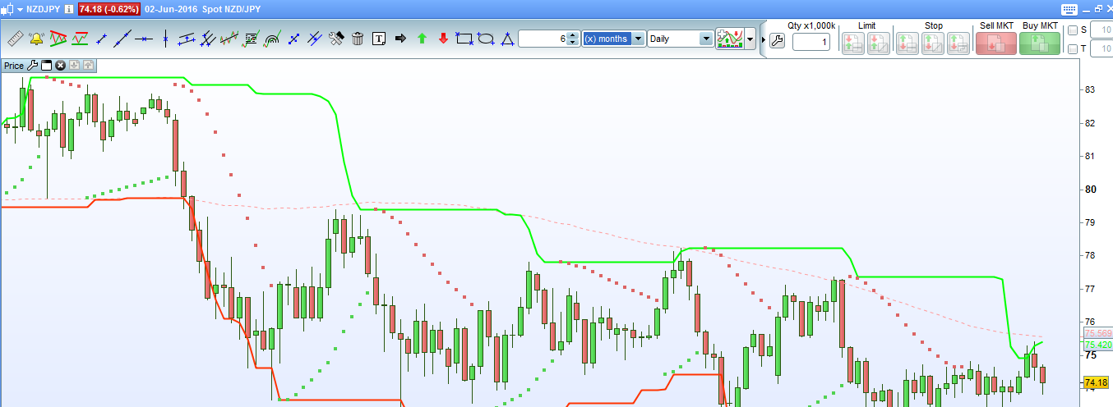
You can see that the closing price is the same as the screener.

